Master Gardeners
of Monmouth County

2021 Howard Bodner Memorial Scholarship
The Monmouth County Master Gardeners are offering several $1,000 scholarships to worthy candidates residing in Monmouth County who have been accepted to matriculate at a college or university for the fall semester of 2021. Previous winners are ineligible.
Current students already enrolled in an acceptable degree program may also apply.
The candidates must be planning to major in Horticulture, Environmental Sciences, Plant Biology/Botany, Environmental Planning and Design or related Agricultural fields.

Scholarship applications are available online at https://tinyurl.com/mgscholarship21
Questions? Please contact us at mgmcscholarship@gmail.com.

The application deadline is April 1, 2021
Winners will be notified by June 1, 2021

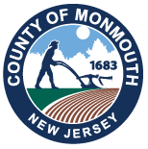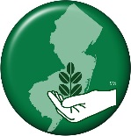
Monmouth County Board of County Commissioners
Thomas A. Arnone, Director
Susan M. Kiley, Deputy Director
Lillian G. Burry, Liaison to Rutgers Cooperative Extension
Nick DiRocco
Ross F. Licitra

